Chapter 7: Matrices and Determinants
7.2 – Operations with Matrices
MATRIX ADDITION
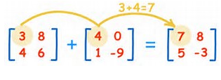
You can add two matrices (of the same order) by adding their corresponding entries.

The sum of two matrices of different orders is undefined.
Practice:
1. $\left[\begin{matrix}-1 & 2 \\ 0 & 1\end{matrix}\right]+\left[\begin{matrix}1 & 3 \\ -1 & 2\end{matrix}\right]=$ 2. $\left[\begin{matrix}0 & 1 & -2 \\ 1 & 2 & 3\end{matrix}\right]+\left[\begin{matrix}6 & -1 & 3 \\ -9 & 5 & 2\end{matrix}\right]=$

3. $\left[\begin{matrix}1 \\ -3 \\ 2\end{matrix}\right]+\left[\begin{matrix}-1 \\ 3 \\ -2\end{matrix}\right]=$ 4. $\left[\begin{matrix}2 & 1 & 0 \\ 4 & 0 & -1 \\ 3 & -2 & 2\end{matrix}\right]+\left[\begin{matrix}0 & 1 \\ 3 & -1 \\ 2 & 4\end{matrix}\right]=$

-----------------------------------------------------------------------------------------------------------------------------
SCALAR MULTIPLICATION
In operations with matrices, numbers are usually referred to as scalars. In this course, scalars will always be real numbers. You can multiply a matrix $A$ by a scalar $c$ by multiplying each entry in $A$ by $c.$
If $=\left[\begin{matrix}2 & 2 & 4 \\ -3 & 0 & -1 \\ 2 & 1 & 2\end{matrix}\right]$ , find $3A$.

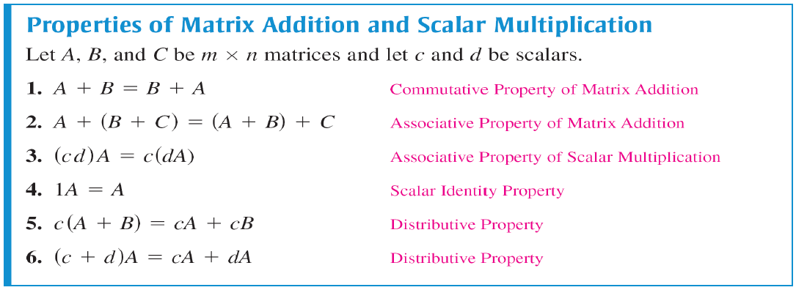
The properties of matrix addition and scalar multiplication are similar to those of addition and multiplication of real numbers.

Practice:
If $A=\left[\begin{matrix}2 & 1 \\ -3 & 4 \\ 1 & 6\end{matrix}\right]$ and $B=\left[\begin{matrix}2 & -3 \\ 0 & 5 \\ -1 & 4\end{matrix}\right]$ find the following.

1. $A+B$ 2. $-A+2B$ 3. $3A-2B$

SOLVING A MATRIX EQUATION
Solve for $X$ in the equation $2X+A=B$, where
$$A=\left[\begin{matrix}1 & -2 \\ 0 & 3\end{matrix}\right] and B=\left[\begin{matrix}-3 & 4 \\ 2 & 1\end{matrix}\right]$$

Practice: Solve for $X$ in the equation, $2X+3A=B,$ for the following matrices.
$$A= \left[\begin{matrix}-2 & -1 \\ 1 & 0 \\ 3 & -4\end{matrix}\right] and B= \left[\begin{matrix}0 & 3 \\ 2 & 0 \\ -4 & -1\end{matrix}\right]$$

MATRIX MULTIPLICATION
For the product of two matrices to be defined, the number of columns of the first matrix must equal the number of rows of the second matrix.
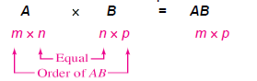
Find the product $AB$ where:
$$A=\left[\begin{matrix}-1 & 3 \\ 4 & -2 \\ 5 & 0\end{matrix}\right] and B=\left[\begin{matrix}-3 & 2 \\ -4 & 1\end{matrix}\right]$$

The product $AB$ has the order ___________.

